Certification Project

Q1. Create an account on Github  
Ans. <https://github.com/ankitraonka>

Q2. Fork the repository that will be created by the trainer for the project  
Ans. 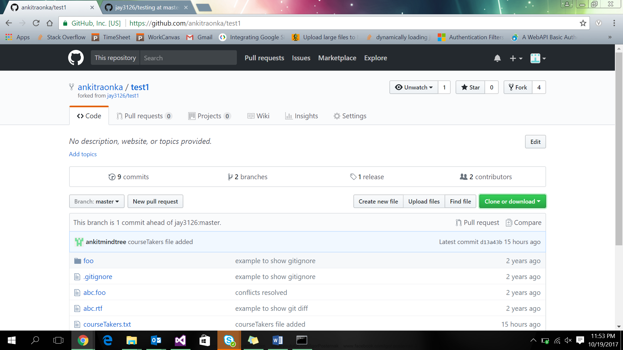

Q3. Clone the forked repository on to local machine  
Ans. git clone <https://github.com/ankitraonka/test1.git>

Q4. Create feature branch on the local machine  
Ans. cd test1  
 git checkout -b featureBranch  
  
Q5. Configure the upstream repo  
Ans

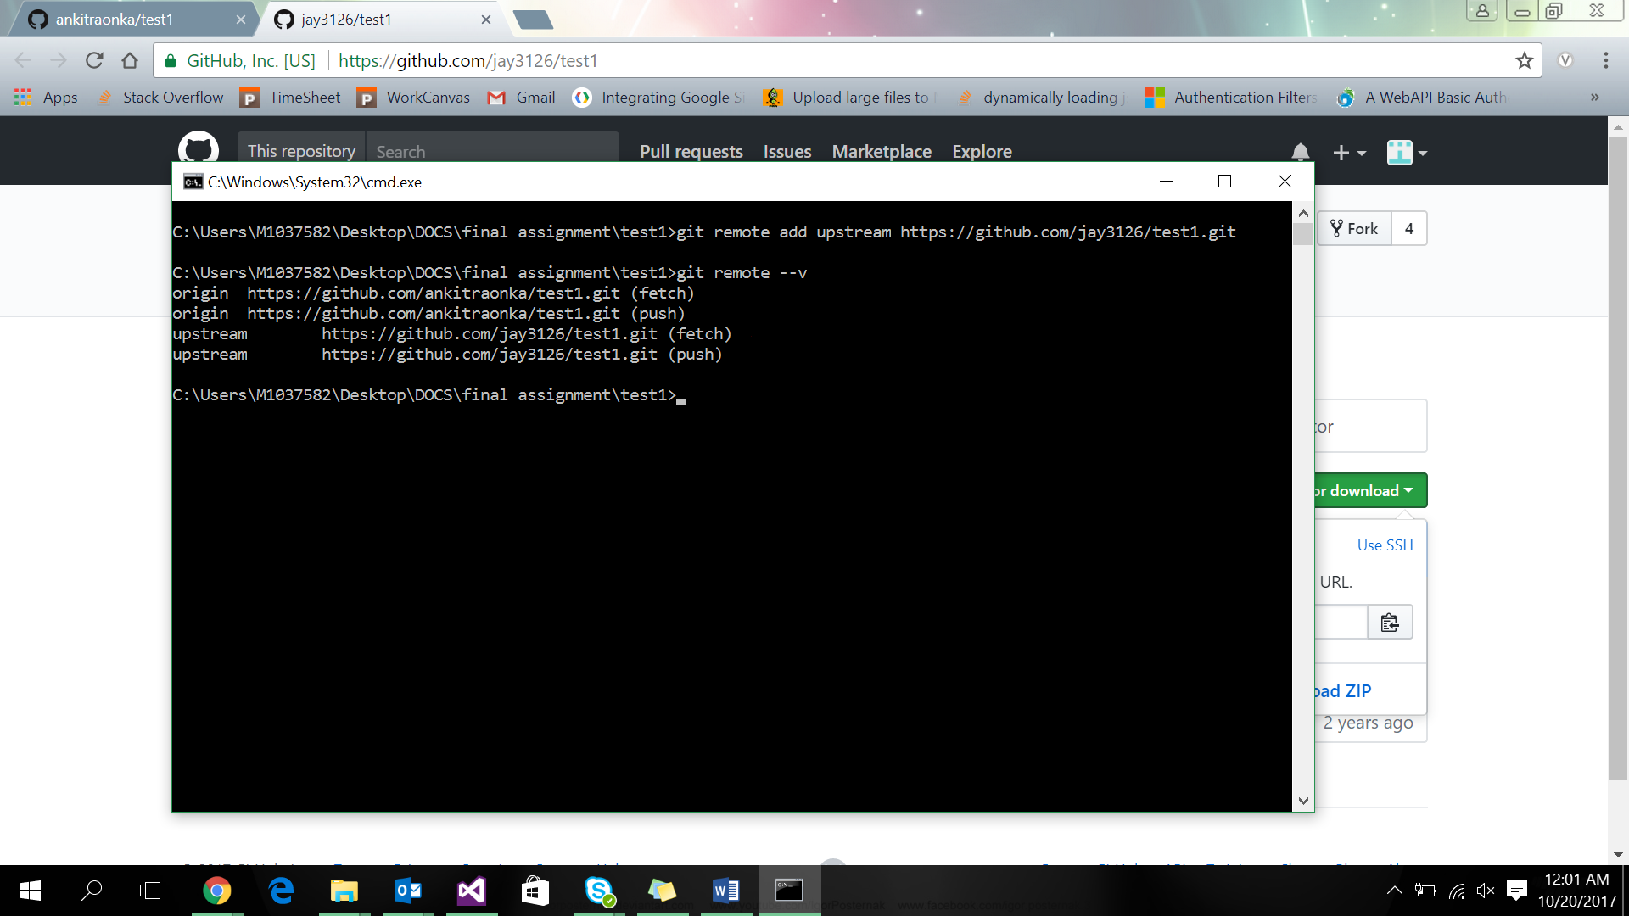

Q6. Add some files, edit the files. remove some files and finally commit the changes to the feature branch and push it to the origin repo  
Ans

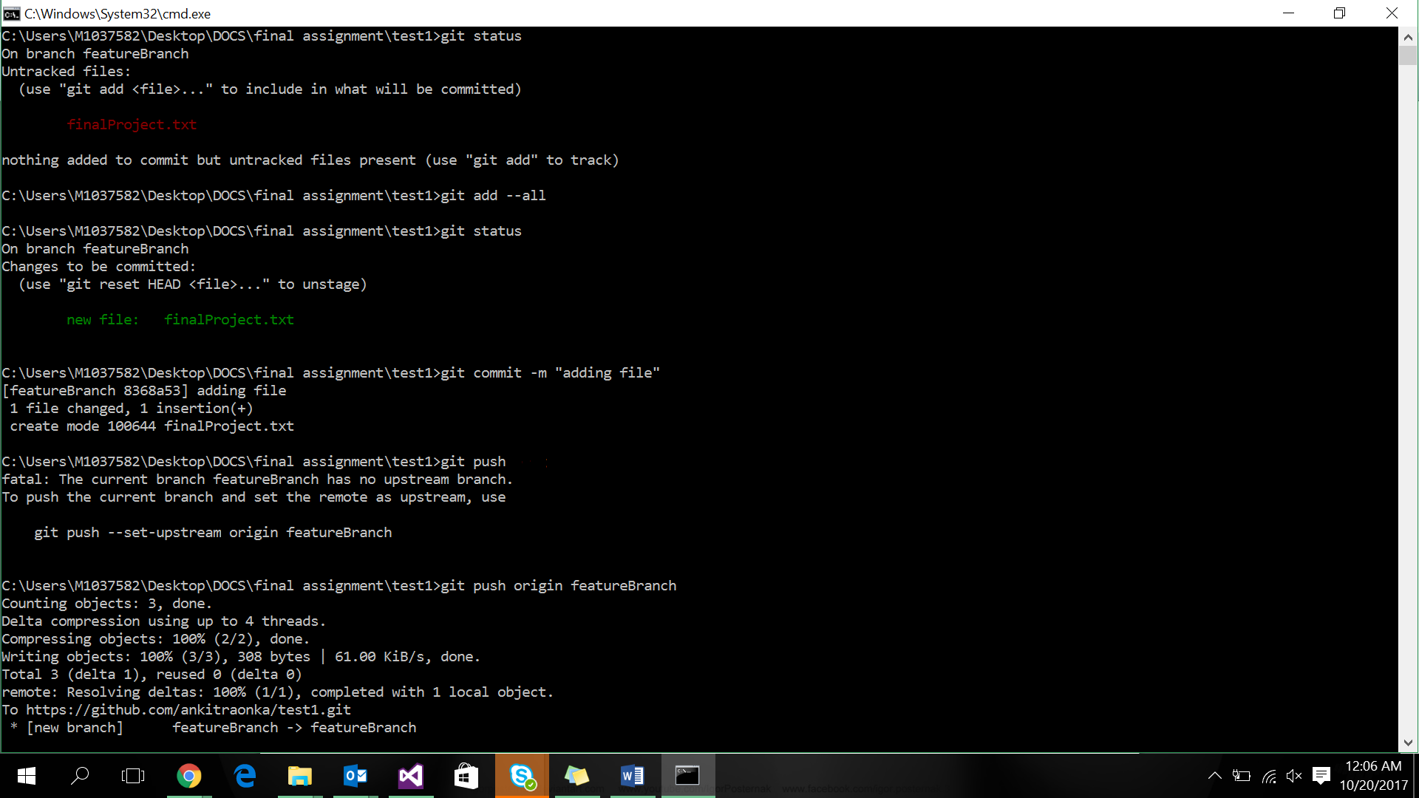

Q7/8. Create a pull request for other developers   
 Work on the pull request feature and provide comments on Github UI  
Ans

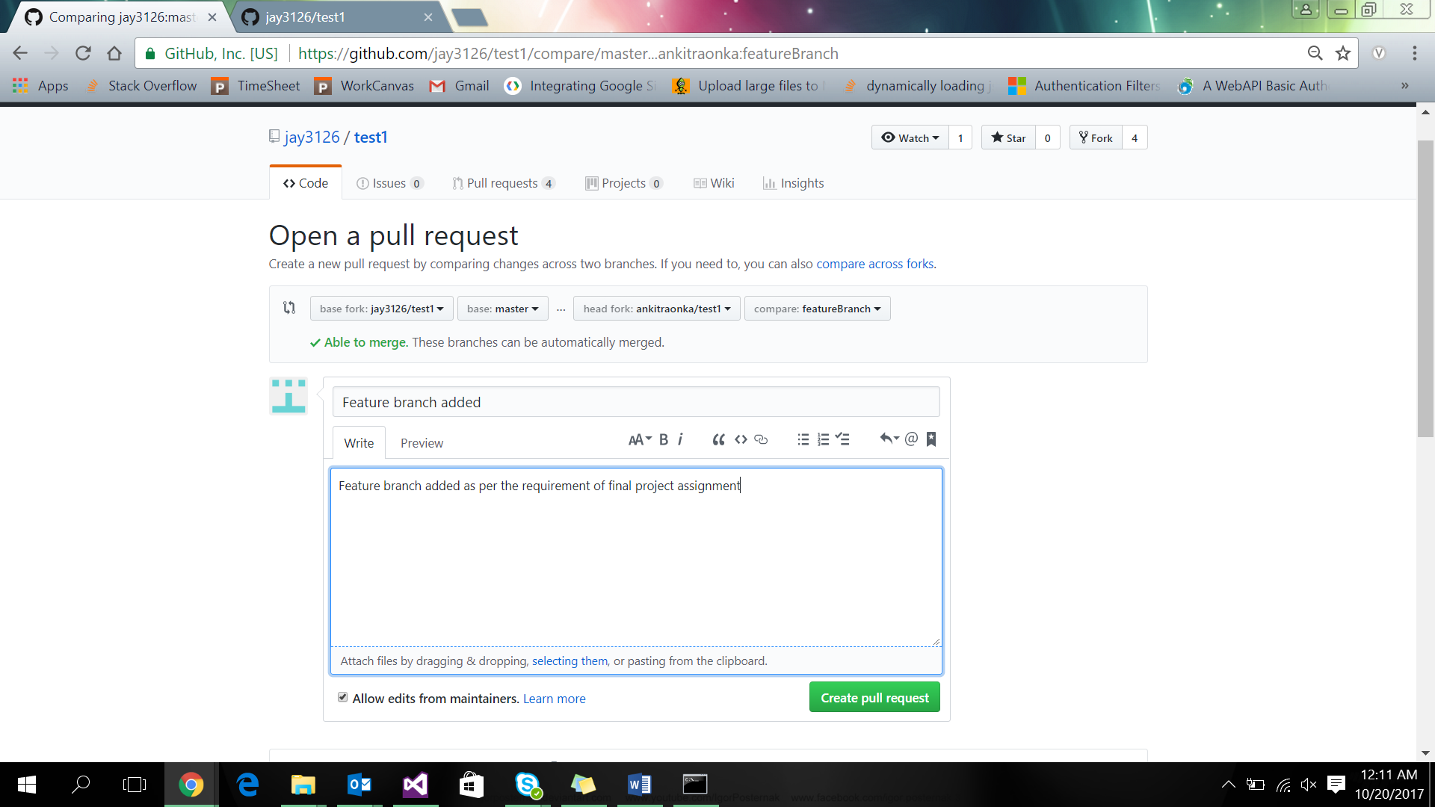

Q9. Merge the changes from the pull repository of other collaborators to their local repo  
Ans

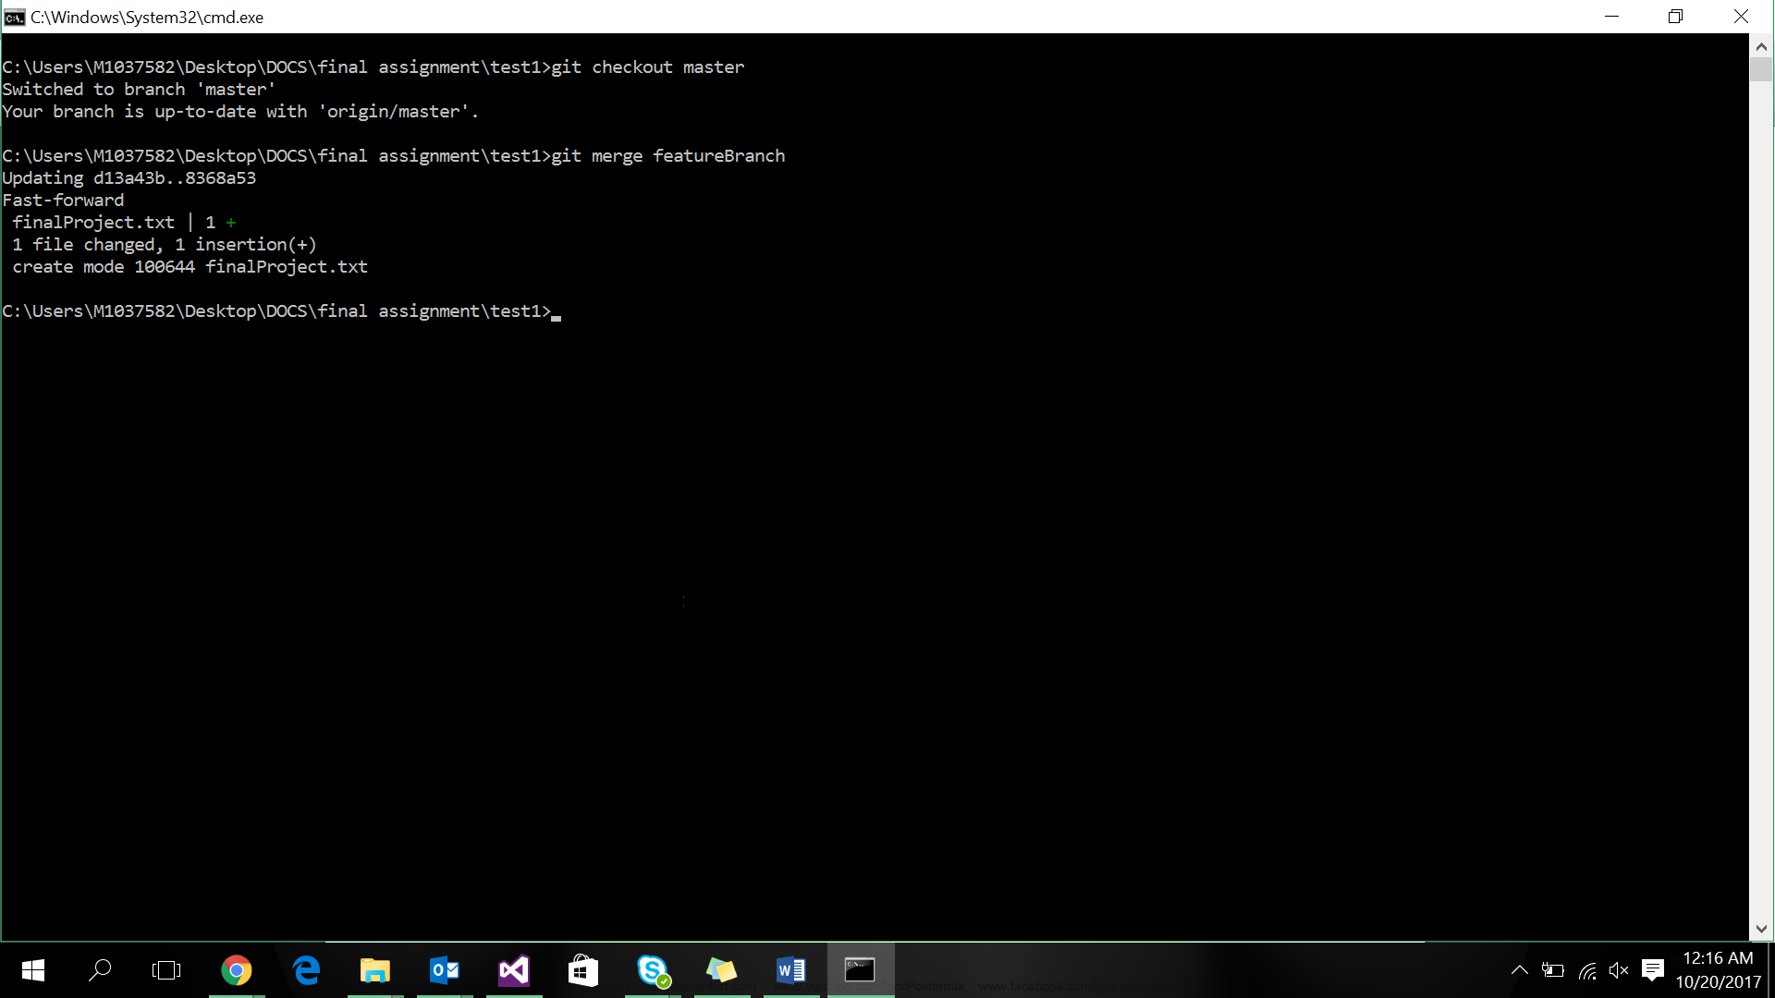

Q10. Push the changes to the main branch and finally delete the feature branches  
Ans

